April 2020 Newscast – Central Iowa Beekeepers Association

Good afternoon!

Where do I start in talking about what your CIBA has been doing the last month? It's relatively easy -- we are postponing everything until this virulent Covid-19 bug can be controlled or at least figured out better!! Life has really changed for all of us but thankfully our bees can still fly and a lot of us can take even more time to tend to them. Postponing our March 21 membership meeting was difficult to do but extremely necessary to protect all of us.

I need to announce that we are postponing our Spring Auction that was scheduled on Saturday, April 18th. As for when we will reschedule is really up to what the success is in controlling Covid-19. Your Officers and Directors will be discussing this in the next month or two and get back to you.

The relatively easy winter and somewhat early spring has spared a lot of our hives so far. March did come in as a lamb does it mean it will go out like a lion? Hives can still die from what I've been told. So make sure that they have enough honey/sugar syrup/winter patties until nectar flow in a couple weeks.

Our Editor, Laura Miller, found the following link to The American Bee Journal so if you do not currently subscribe you can at least read the latest Journal. https://americanbeejournal.com/

Please feel free to contact me or any of your Officers or Directors for questions or comments.

Stay healthy!!

Jamie Beyer
CIBA President

Leaving you with some humor; these days we could all use a good giggle!

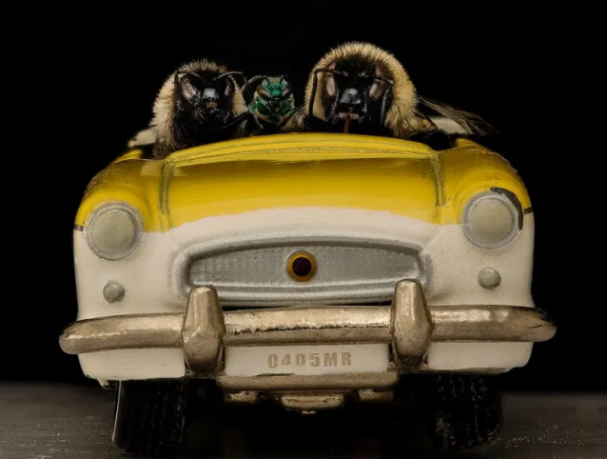
Are we there yet? You know, we could have flown.

